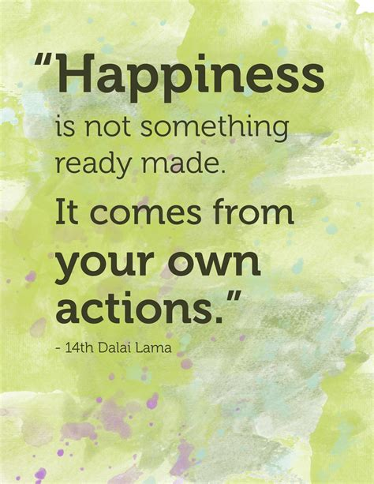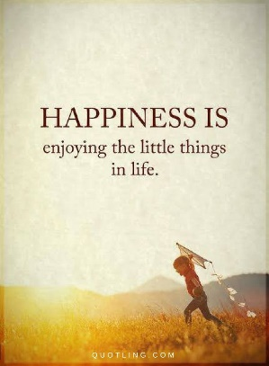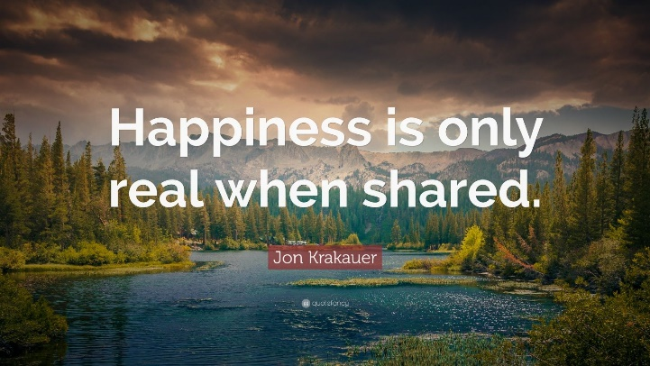
Hi everybody!
we are already at the beginning of week 7 of Corona break and life feels different, doesn’t it?
Our topic is still Food & Health – this week we will concentrate on our mental health. How are we feeling at the time when we get bad news and feel insecure? Wie geht es uns in dieser Zeit, wenn wir schlechte Nachrichten bekommen und uns unsicher fühlen? Maybe we have more time to think about what really matters in life, what we need for a happy life. Vielleicht haben wir mehr Zeit um nachzudenken über das, was wirklich zählt im Leben und was wir zum Glücklichsein brauchen.
Wir sehen uns voraussichtlich schon nächste Woche – mit Maske, aber zumindest wieder ‚Face to Face‘. Bis dahin habe ich noch ein paar Sachen vorbereitet.
Beginnt mit diesen Übungen. Gut, um die richtige Satzstellung im Englischen zu üben:
https://www.liveworksheets.com/worksheets/en/English_as_a_Second_Language_(ESL)/Word_Order/Word_Order_he27188hv
https://www.liveworksheets.com/yt19160um
Revision / warm-up  Grammar  Vocabulary/new language  Reading & Watching | Countable/uncountable nouns  Present continuous  Feelings  My perfect day  Video about the science of happiness  The happiness quiz | worksheet (email attachment):  - Countable/uncountable nouns2 (+ Lösungen – selbst korrigieren!)  First watch this video:  https://youtu.be/0djfJqWhnpY  worksheet (attachment):  - Present continuous  - Present continuous questions  (+Lösungen – selbst korrigieren)  worksheet (email attachment):  - send a screenshot – you can check your answers if you want  worksheet (email attachment)  - Listen to the MP3s and fill in the words (send a screenshot)  watch the video:  https://youtu.be/e9UVAafNvm4  Then answer these questions (send screenshot):  - What are the 7 ways that make people happier?  - What makes you happy? Give some examples.  - Which of the 7 ways of happiness work for you? Why?  - Try out one of them next time and talk about your experience when we meet again  worksheet (email attachment)  - Do the quiz and do exercise 1+4: write down your answers in present continuous tense! (send screenshot)  The rest we do in class!!

