4th Short test: Describe rooms, word order, British homes
name: __________________
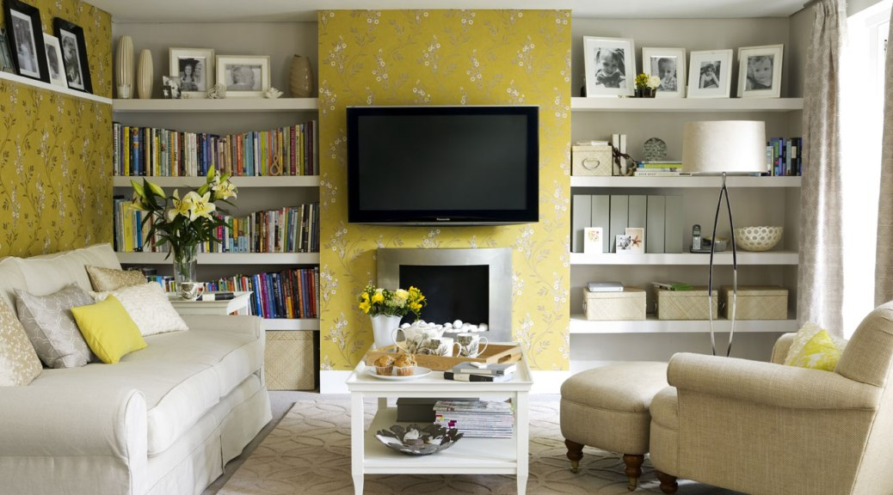
- Write 5 sentences about what you can see in the picture and where it is (use there is & prepositions of place)
____________________________________________________________________________________________________________________________________________________________________________________________________________________________________________________________________________________________________________________________________________________________________ / 8
- Describe a typical British house ___________________________________________________________________________________________________________________________________________________________________________________________________________ /4

- Find the opposite adjectives
small
cheap
noisy
new
/4
- Find the right word order

cats /usually/ at/ sleep/ don’t/ night ______________________________________.
usually/what/have/do/you/breakfast/for? __________________________________?
at 8.15/our English class/starts/always ____________________________________ .
drinks/she/every morning/three cups of tea ________________________________ .
/4

